Laboratory Safety Fact Sheet
Hazardous Waste Management
This laboratory safety fact sheet summarizes the types of waste that require segregation and disposal at approved hazardous waste treatment plants and those that can be disposed of through the municipal system.

Chemical Waste
Chemical waste should be disposed of in standard chemical waste containers provided by the licensed contractor, ECOSPACE. The standard liquid chemical waste container should be put inside a spill tray and affixed with a standard warning label prominently. The Chemical Waste Log Sheet should be filled out properly with information on names of chemicals, quantities and names of persons who dispose of chemical waste. Request empty chemical waste containers and collection service by this hyperlink: https://hseo.hkust.edu.hk/form/request-for-chemical-waste-coll
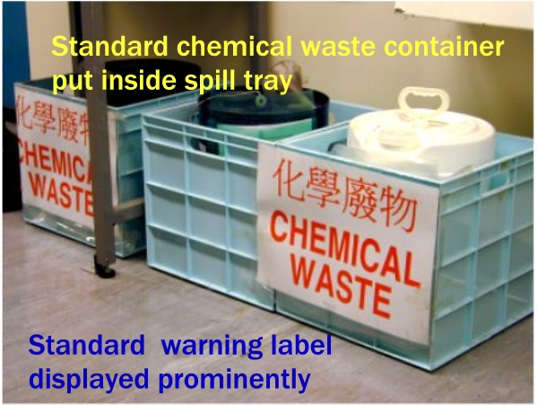

Silica Gel Wastes
Used silica gel, molecular sieves and desiccants should be dried in a fume cupboard. Transfer them to rigid containers (e.g. a wide-mouth plastic reagent bottle), add water to keep them moist, seal the container and then discard them as municipal waste.

Glass or Sharp Wastes
Broken reagent bottles, glassware and vials (must be emptied and cleaned) should be put in the broken glass cartons labeled “Broken Glass Waste”. Call CLS at 6884 or 6887 to order new broken glass cartons and collection service.

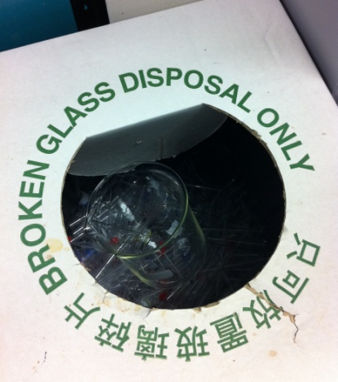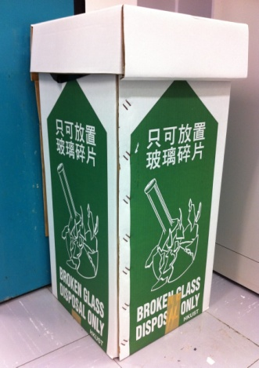

Needles or sharps such as razor blades and glass slides should be collected in a plastic sharp box and disposed of as municipal waste. Sharps with biological contamination should be sterilized before disposal. Call CLS at 6875 or 6876 to order new plastic sharp boxes.

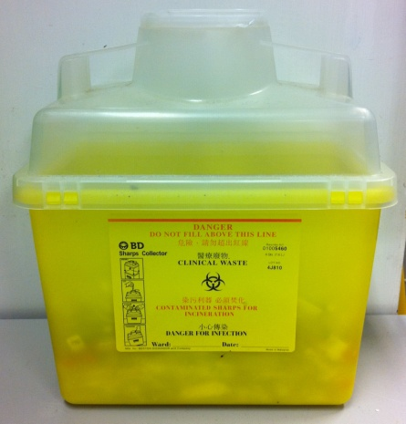

Biohazard Wastes
Biohazard waste should be collected in an autoclave bag and placed in a waste container labeled “BIOHAZARD” and kept in a laboratory instead of a service corridor. The STERILIZED biohazard waste can be dumped into the garbage bin as municipal waste. Call CLS at 6875 or 6876 to order autoclave bags.

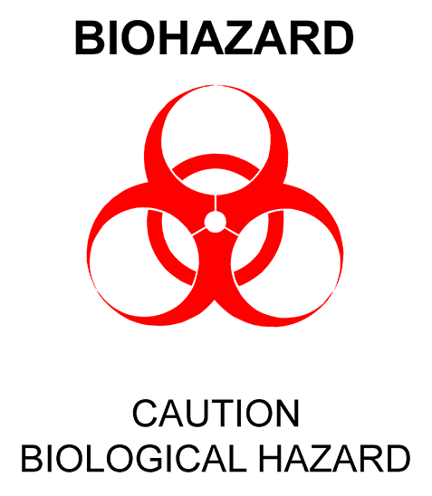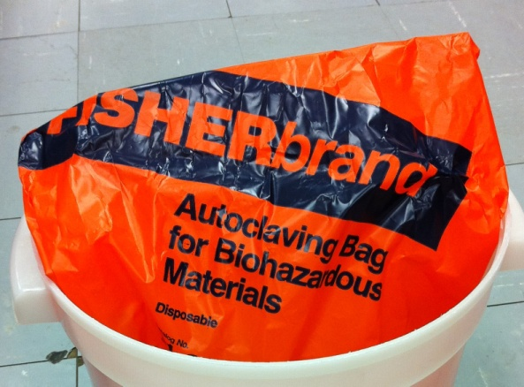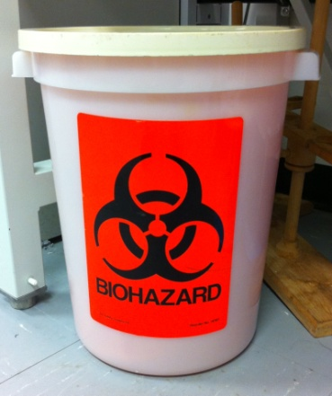

Empty Glass and Plastic Chemical Containers
Empty glass and plastic solvent containers should be air-dried in a well-ventilated fume cupboard. If the residual chemical is found in an empty glass and plastic containers, they should be first triple rinsed with water or any solvent suitable for removing the chemical and then air-dried in a well-ventilated fume cupboard. Call CLS at ext. 6884 or 6887 for collection service.

